Task
Task 1
- Replace old dr/author bio page with this new,
- replace dr dashboard my profile section with this dr dashboard my profile section and
- replace old doctor section of admin panel with this admin panel dr profile section but keep below section from old doctor section of admin panel
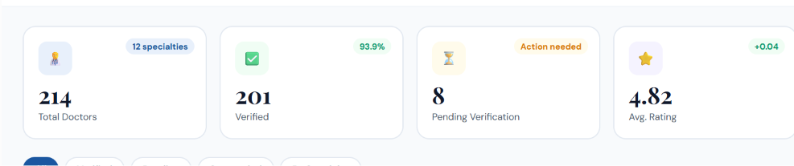

Task 2
Replace old patient panel with new attached panel

Task 3
Add following from attached Dr dashabord to old one

1. Patient Q&A
- New Questions
- Pending Answers
- Answered
- Rejected

2. Online Consultation
- Requests
- Upcoming Consultations
- Today's Consultations
- Ongoing Consultations
- Completed
- Cancelled
- Consultation History
Doctor Availability
- Online Availability & Slots

3. Physical Appointments
- Appointment Requests
- Upcoming Appointments
- Today's Appointments
- Manual Appointments
- Completed
- Cancelled
Clinic Schedule
- Working Hours & Slots

Task 4.
Add following from attached Admin panel to old
1. Patient Q&A
- Pending Questions
- Approved Questions
- Rejected Questions
- Answered
- Reports

2. Consultation Management
- Pending
- Approved
- Upcoming
- Ongoing
- Completed
- Cancelled
- Reports
- Prescriptions
3. Physical Consultation Requests
- Pending
- Approved
- Rejected
- Upcoming
- Completed
- Cancelled

All section are interlinked with each other

Task 5
Modify step 1 of old booking page with this attached new one but still we to set it

